Name: Muhammad Uzair

Roll No. L1F18BSCS0311

Section - F

**Apply BFS on the graph given below and show all steps. [parent, distance and color]  
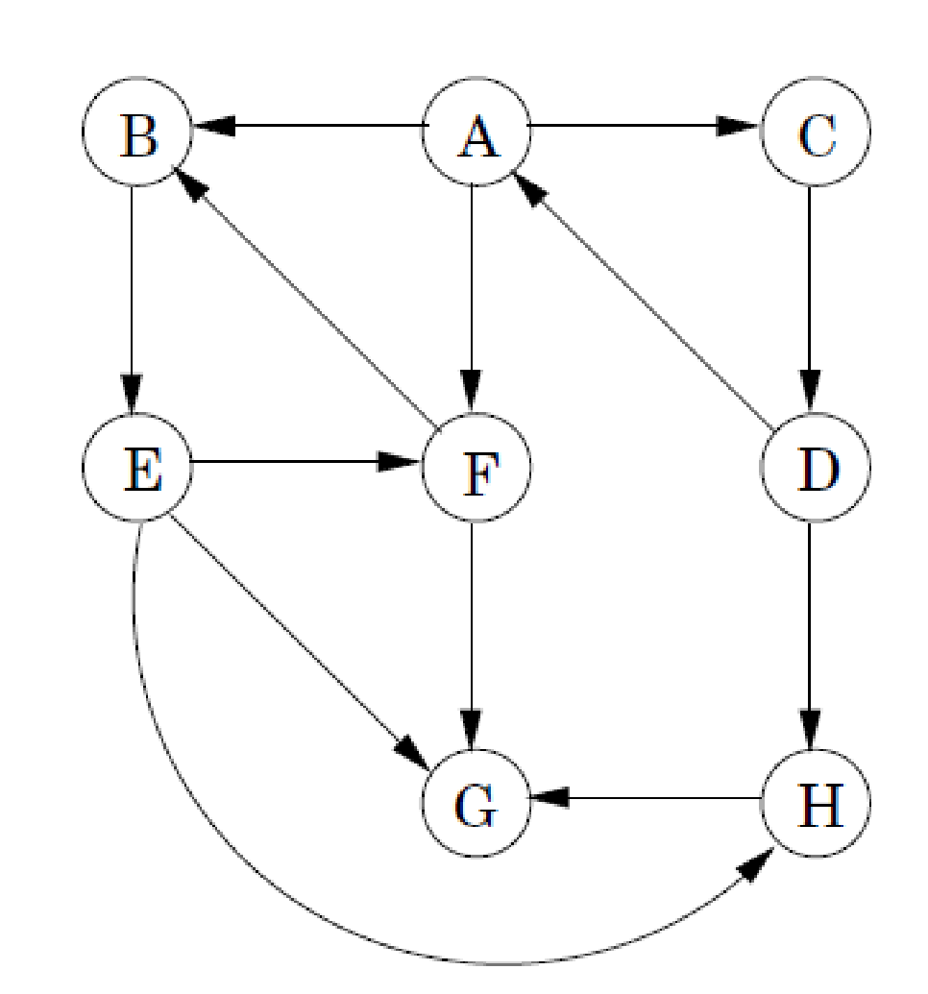  
Part 1 -   
Starting vertex is F  
What important point you have understood from this application?**

|  |  |  |  |  |  |  |  |  |  |
| --- | --- | --- | --- | --- | --- | --- | --- | --- | --- |
|  | A | B | C | D | E | F | G | H | Queue |
|  | inf/nil/W | inf/nil/W | inf/nil/W | inf/nil/W | inf/nil/W | 0/nil/G | inf/nil/W | inf/nil/W | **F** |
| **F/0/NIL** | inf/nil/W | 1/F/G | inf/nil/W | inf/nil/W | inf/nil/W | 0/nil/G | 1/F/G | inf/nil/W | **B G** |
| **B/1/F** | inf/nil/W | 1/F/G | inf/nil/W | inf/nil/W | 2/B/G | **0/nil/B** | 1/F/G | inf/nil/W | **G E** |
| **G/1/F** | inf/nil/W | **1/F/B** | inf/nil/W | inf/nil/W | 2/B/G | **0/nil/B** | 1/F/G | inf/nil/W | **E** |
| **E/2/B** | inf/nil/W | **1/F/B** | inf/nil/W | inf/nil/W | 2/B/G | **0/nil/B** | **1/F/B** | 3/E/G | **H** |
| **H/3/E** | inf/nil/W | **1/F/B** | inf/nil/W | inf/nil/W | **2/B/B** | **0/nil/B** | **1/F/B** | 3/E/G |  |
|  | 4/nil/G | **1/F/B** | inf/nil/W | inf/nil/W | **2/B/B** | **0/nil/B** | **1/F/B** | **3/E/B** |  |

Total weight =0 + 1 + 1 + 2 + 3 = 7

Maximum distance from F = 3

**Part 2 -  
Starting vertex is D  
What important point you have understood from this application?**

|  |  |  |  |  |  |  |  |  |  |
| --- | --- | --- | --- | --- | --- | --- | --- | --- | --- |
|  | A | B | C | D | E | F | G | H | Queue |
|  | inf/nil/W | inf/nil/W | inf/nil/W | 0/nil/G | inf/nil/W | inf/nil/W | inf/nil/W | inf/nil/W | **D** |
| **D/0/NIL** | 1/D/G | inf/nil/W | inf/nil/W | 0/nil/G | inf/nil/W | inf/nil/W | inf/nil/W | 1/D/G | **A H** |
| **A/1/D** | 1/D/G | 2/A/G | 2/A/G | **0/nil/B** | inf/nil/W | 2/A/G | inf/nil/W | 1/D/G | **H B C F** |
| **H/1/D** | **1/D/G** | 2/A/G | 2/A/G | **0/nil/B** | inf/nil/W | 2/A/G | 3/H/G | 1/D/G | **B C F G** |
| **B/2/A** | **1/D/B** | 2/A/G | 2/A/G | **0/nil/B** | 4/B/G | 2/A/G | 3/H/G | **1/D/B** | **C F G E** |
| **C/2/A** | **1/D/B** | **2/A/B** | 2/A/G | **0/nil/B** | 4/B/G | 2/A/G | 3/H/G | **1/D/B** | **F G E** |
| **F/2/A** | **1/D/B** | **2/A/B** | **2/A/B** | **0/nil/B** | 4/B/G | 2/A/G | 3/H/G | **1/D/B** | **G E** |
| **G/3/H** | **1/D/B** | **2/A/B** | **2/A/B** | **0/nil/B** | 4/B/G | **2/A/B** | 3/H/G | **1/D/B** | **E** |
| **E/4/B** | **1/D/B** | **2/A/B** | **2/A/B** | **0/nil/B** | 4/B/G | **2/A/B** | **3/H/B** | **1/D/B** |  |
|  | **1/D/B** | **2/A/B** | **2/A/B** | **0/nil/B** | **4/B/B** | **2/A/B** | **3/H/B** | **1/D/B** |  |

Total weight = 0 + 1 + 1 + 2 + 2 + 2 + 3 + 4 = 15

Maximum distance from D = 4

**Important concepts to understand – with reason  
Maximum number of vertices in queue at any time  
Minimum number of vertices in queue at any time  
In queue vertices what is maximum difference related to distance  
In queue vertices what is minimum difference related to distance  
Parent relation to find path in the resultant graph [logically how we can find]**